Driver Drowsiness Detection System



By

Saadat Ali FA18-BCS-019

Salman Hussain FA18-BCS-071

Waqar Ul Hassan FA18-BCS-025

Project Supervisor

_______________

Mr. Muhammad Adnan

Department of Computer Science and Information Technology

Mirpur University of Science and Technology

June, 2022

CERTIFICATION

It is certify that the following students have completed their project on

“**Driver Drowsiness Detection System”**.

Submitted By:

Saadat Ali FA18-BCS-019

Salman Hussain FA18-BCS-071

Waqar Ul Hassan FA18-BCS-025

**Session: 2018-22**

This report is submitted in partial fulfillment of the requirements of the award of degree of **Bachelors of Computer Science.** Mirpur University of Science and Technology (MUST)

**_____________________ __________________**

**External Examiner Project Supervisor**

(Mr. Muhammad Adnan)

**________________________________**

**Chairman**

Department of Computer Science

MUST Mirpur (A.K)

ABSTRACT

One of the most common causes of car accidents is drowsiness and fatigue. They can be avoided by getting sufficient sleep before driving, drinking coffee or an energy drink before driving, or taking a break when the feelings of tiredness appear. Complex methods, such as EEG and ECG, are used in the popular drowsiness detection approach. This method offers a high level of measurement accuracy, but it requires touch measurement and has a number of drawbacks when it comes to driver fatigue and drowsiness monitoring. As a result, it is inconvenient to utilize in real-time driving**.** This paper proposes a way to detect the drowsiness signs among drivers by measuring the eye closing rate.

Through this project, an in-depth study of various existing techniques of  
drowsiness in a driver is studied, followed by developing a deep learning based model to accurately identify a driver’s state using a novel technique of using facial features of the face. It can be determined that the accuracy will remarkably increase when this technique is used. The designed system deals with detecting the face area of the image captured from the video. The purpose of using the face area so it can narrow down to detect eyes within the face area. Once the face is found, the eyes are found by creating the eye for left and right eye.

The parameters of the eyes detection are created within the face image. The video were change into images frames per second. From there, locating the eyes can be performed. Once the eyes are located, measuring the intensity changes in the eye area determine the eyes are open or closed.

If the eyes are found closed for minimum threshold frames consecutively, it is confirm that the driver is in drowsiness condition.

UNDERTAKING

I certify that research work titled “*Driver Drowsiness Detection System”* is our own work. The work has not, in whole or in part, been presented elsewhere for assessment. Where material has been used from other sources it has been properly acknowledged/ referred.

_______________

Saadat Ali

FA18-BCS-019

_______________

Salman Hussain

FA18-BCS-071

_______________

Waqar Ul Hassan

FA18-BCS-025

ACKNOWLEDGEMENTS

All the praise and glory to Allah, Who has blessed us with the courage and knowledge to achieve our goal. We can never thank Him enough for His countless blessings upon us. Praise to Prophet Muhammad (S.A.W), who is and will always be a source of guidance and knowledge for humanity as a whole.

I am thankful to all those persons because the activity if going through industrial orientation it’ll bridged me to become good IT Professional. Naturally, it requires lot of people support to complete this project. We take this opportunity to acknowledge their support to us. First of all I am extremely thankful to Mirpur University of Science, Software Engineering department and for giving permission to do project.

We consider our self-privileged having found an opportunity to express our heartily thanks to our Supervisor Mr. Muhammad Adnan.

The success of any project is never limited to the individual undertaking the project. However, there are some key personalities whose role is very vital in project. So i greatly obliged to express my gratitude to all the mentioned officials of MUST Computer Science and Information Technology Faculty for giving me assistance, guidance, inspiration in this project.

With sincerely regards,

Saadat Ali

Salman Hussain

Waqar Ul Hassan

**Table of Contents**

1 INTRODUCTION 1

1.1 Motivation 1

1.2 Overview 2

1.1.1 Background of Study 2

1.1.2 Significance of This Project 2

1.1.3 Problem Statement 2

1.1.4 Objectives 3

1.1.5 Relevancy of the Project 3

2 LITERATURE REVIEW & METHODOLOGY 4

2.1 Drowsiness and Fatigue 4

2.2 Driver Drowsiness Detection Techniques 4

2.2.1 Electroencephalography (EEG) for Drowsiness Detection 5

2.2.2 Drowsiness detection using face detection system 6

2.2.3 PERCLOS (Percentage of Eye Closure) 6

2.2.4 Yawning Detection Method 7

2.3 A Comparative Study Of DDT 8

2.4 CLASSIFICATION METHODS USED FOR DDT 9

2.4.1 SUPPORT VECTOR MACHINE (SVM) 10

2.4.2 HIDDEN MARKOV MODEL (HMM) 10

2.4.3 CONVOLUTIONAL NEURAL NETWORKS (CNN) 10

3 SYSTEM DESIGN 13

3.1 Use Case Diagram 13

3.2 Activity Diagram 14

3.3 Class Diagram 15

3.4 Block Diagram 16

4 SYSTEM REQUIREMENTS AND SPECIFICATION 17

4.1 Software Requirements Specification 17

4.1.1 Anaconda (1.9) 17

4.1.2 Python (3.7) 17

4.1.3 Jupyter Notebook (6.0.3) 17

4.1.4 Libraries 17

4.1.5 Operating System 17

4.2 Hardware Requirements Specification 17

4.3 Requirement Analysis 18

4.3.1 Anaconda 18

4.3.2 Python 18

4.3.3 Jupyter Notebook 18

4.3.4 Google Colab 19

4.4 Libraries 19

4.4.1 Operating System 19

4.4.2 Laptop 19

4.4.3 Webcam 19

5 Implementation 20

5.1 Dataset Collection 20

5.2 CNN Architecture 20

5.3 Procedure 21

5.3.1 Step 1: Take a picture from a Laptop Cam as input 21

5.3.2 Step 2: Detecting Faces in Images and Creating Regions of Interest (ROI) 21

5.3.3 Step 3: Extract the eyes from the ROI and input them to the classifier 22

5.3.4 Step 4: The classifier will determine if the eyes are open or closed 22

5.3.5 Step 5: Calculate Score to Check whether Person is Drowsy or Not 23

5.4 GUI Design 23

5.5 Final Experiment Results 24

5.5.1 Main Application: 24

5.5.2 App Menus & Submenus: 25

5.5.3 Open & Close Eye 27

5.5.4 Open & Close Eye With Glasses 29

6 CONCLUSION 31

Limitations 31

6.1.1 Ambient light dependence:- 31

6.1.2 Optimal range required:- 31

6.1.3 Hardware requirements:- 32

6.1.4 Problem with multiple faces:- 32

7 REFERENCES 33

List of Figures

Figure 1: Statistic of Road Accident from 2004 to 2013 in Pakistan 1

Figure 2: Architecture of drowsiness detection techniques. 5

Figure 3 : Comparative graph of DDT 8

Figure 4: Comparative graph of classifiers 12

Figure 5: Interface of Application 24

Figure 6: Submenus 25

Figure 7: Submenu Clicked 25

Figure 8: Starting Application 26

Figure 9: Open Eyes Detection Straight 26

Figure 10: Close Eye Detection Straight 27

Figure 11: Close Eye Side Pose 27

Figure 12: Open eye side pose 28

Figure 13: Open Eye With Glasses 28

Figure 14:Close Eye With Glasses 29

List of Tables

Table 1: Pros and cons of each technique 9

Table 2: Pros and cons of classifiers 11

Table 3: Drowsiness detection systems using CNN 12

Abbreviations

|  |  |
| --- | --- |
| *DDD* | Driver drowsiness detection |
| *IoT* | Internet of things |
| *ML* | Machine learning |
| *PERCLOS* | Percentage of eyelid closure |
| *EAR* | Eye aspect ratio |
| *SVM* | Support vector machine |
| *KNN* | K-nearest neighbor |
| *RF* | Random forest |
| *ANN* | Artificial neural networks |
| *CNN* | Convolutional neural network |
| *EEG* | Electroencephalography |
| *ECG* | Electrocardiography |
| *EOG* | Electrooculography |
| *DDT* | Driver drowsiness Technique |
| *HF* | High frequency |
| *LF* | Low frequency |

# INTRODUCTION

## Motivation

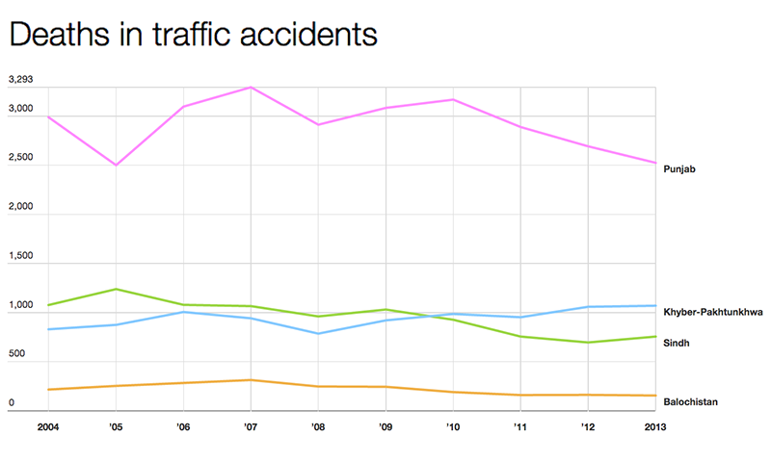Drowsiness is a near-sleep condition defined by a strong desire to sleep. It has two distinct meanings, referring to both the normal state before falling asleep and the health illness of being in that state without regard to a normal cycle. When performing duties that require constant concentration, such as driving a car, sleepiness might be harmful. When a person is extremely tired while driving, they will become drowsy, which increases the risk of a road accident.

Figure 1: Statistic of Road Accident from 2004 to 2013 in Pakistan

A major problem in the field of accident avoidance systems is the development of technology for detecting or preventing drowsiness while driving. Because of the dangers that drowsiness poses on the road, measures for counteracting its effects must be discovered.

## Overview

### Background of Study

In Pakistan, there is an increase in the number of traffic accidents involving cars and heavy vehicles such as buses, lorries, and trucks each year. One of the primary causes contributing to vehicle accidents is drowsiness and fatigue. Driving in this situation can have disastrous consequences because it affects the driver's judgement and focus. Drivers can avoid falling asleep at the wheel if they make measures such as obtaining enough sleep before driving, consuming coffee, or stopping for a short period of time to rest when signs of exhaustion and drowsiness arise.

### Significance of This Project

In Pakistan, drowsiness and tiredness are the leading causes of vehicle accidents. As a result, Driver Drowsiness Detection Using Webcam is being introduced in order to limit and reduce the number of accidents involving vehicles, lorries, and trucks. It identifies drowsiness signals and notifies drivers when they are drowsy.

### ****Problem Statement****

A significant difficulty in the development of accident prevention systems is the detection or prevention of driver drowsiness. Because of the hazard that drowsiness on the road, solutions need to be devised for counteracting its consequences. The purpose of this project is to develop a model of drowsiness detecting system. The focus will be focused on developing a system that would precisely monitor the open or closed condition of the driver’s eyes.

A sleepiness detection system which use a camera situated in front of the driver is more suitable  to be use but the physical indicators that would suggest drowsiness need to be found first in order to  come up with a drowsiness detection model that is dependable and accurate. Lighting intensity  and while the driver tilt their face left or right are the problems develop during detection of eyes area.

Therefore, this project intends to assess all the existing research and method, hence suggest way to detect drowsiness by using video or webcam. It analyses the video images that have been recorded and come up with a method that can analyses each frame of the video.

### Objectives

The project focuses on these objectives, namely:

• Suggesting ways to detect drowsiness while driving.

• To investigate the physical changes of drowsiness.

• To develop a system that use eyes closure a way to detect fatigue and drowsiness.

### Relevancy of the Project

This project is important for its implementation as tired and sleepy drivers contribute to the percentage of road accidents. A lot of research has been done to implement safe driving systems to reduce road accidents. Driver alertness and drowsiness are an effective way to prevent road accidents. Through this program, drowsy drivers will be notified of an alarm to control drivers' awareness, attention and concentration. And also number of road accidents will be reduced by this practice.

# LITERATURE REVIEW & METHODOLOGY

There is a lot of previous research on the driver's drowsiness system that can be used as a reference to develop a real-time system to drive drowsiness. There are also a number of methods that use different methods to detect sleep symptoms. According to available data from Statistic of Road Accident for 2009 to 2020, a total of 104,105 accidents are reported in Pakistan including 44,959 fatal and 59,146 non-fatal accidents. Due to these accidents, 55,141 people [8] have died while 126,144 were found injured.

## Drowsiness and Fatigue

Antoine Picot et al, [4] said that drowsiness is when a person is in the middle of a state of alertness and drowsiness. This situation results in the driver completely not paying attention to their driving. Therefore, the car can no longer be controlled because the driver is in a state of negligence. According to Gianluca Borghini et al, [5] mental fatigue is a contributing factor in sleep and causes hearing loss because it reduces brain function in response to sudden events.

## Driver Drowsiness Detection Techniques

This chapter provides a full overview of the drowsiness detection techniques mentioned, as well as their benefits and drawbacks. Furthermore, a comparison of such techniques is performed on various sorts of driving conditions. Depending on the technique utilized, the Driver Drowsiness detection system continuously analyzes the drivers' physical behavior, vehicular movement pattern, or environmental factors.

Drowsiness detection methods are broadly divided into three categories:

1) Parameter-based behavioral approaches

2) Techniques using vehicle parameters

3) Techniques based on physiological factors

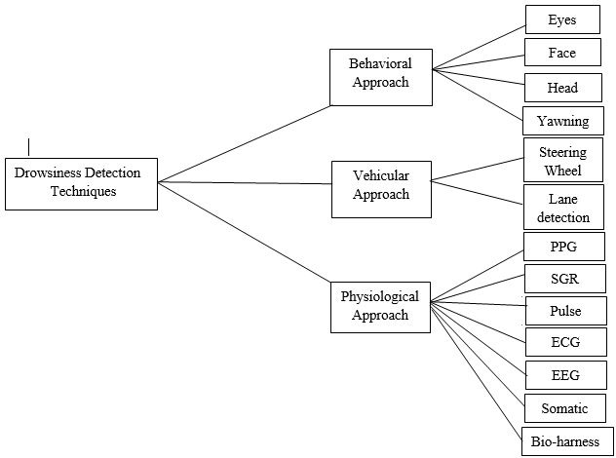

Figure 2: Architecture of drowsiness detection techniques.

Here are some important techniques being used for driver drowsiness detection.

### Electroencephalography (EEG) for Drowsiness Detection

Electroencephalography (EEG) is a technique for measuring electrical activity in the brain. It can detect heartbeats, eye blinks, and even large physical movements like head movement. It can be used on humans or animals to measure brain activity. It employs a unique apparatus that installs sensors around the top of the head to detect any electrical brain activity. Authors have indicated that from the method that has been used to collect EEG data.

The EEG approach was best used by the previous researcher to detect sleepy indicators. to be used for detecting drowsiness and weariness EEG has four types in the approach. There are four frequency components that can be analyzed: alpha (), beta (), theta (), and delta (). When The increasing power in the alpha () and delta () frequency regions indicates that the driver is dealing with weariness and drowsiness One of the limitations of this approach is that it is extremely sensitive to noise near the sensors. For For example, when performing an EEG experiment, the surrounding area must be kept clean. utter silence The noise will disrupt the sensors that detect brain activity. Another The downside of this method is that, while the outcome may be accurate, it is unsuitable for usage for real-world driving use Consider a driver who is wearing something on his head. A head full of wires, and when the driver lifts their head, the wire may come undone place. Even though it is inconvenient for real-time driving, it is useful for testing. It is one of the greatest ways so far for purposes and data collection.

### Drowsiness detection using face detection system

Face area detection can be used to identify drowsiness. The methods for detecting drowsiness in the face area differ because drowsiness signs are more evident and clear to detect in the facial area. The location of the eyes can be determined from the face area. According to the author, there are four forms of eyelid movement that can be utilized to detect tiredness. They are fully open, fully closed, and in the middle, where the eyes go from open to close and vice versa.

The algorithm processes the captured images in grey-scale mode, where the colour from the images is then converted to black and white. Working with black and white photos is more straightforward because just two factors must be measured. The author then uses edge detection to detect the edges of the eyes, allowing the amount of eyelid area to be determined.

The issue with this procedure is that the size of the eyeball area varies from person to person. Some people have tiny eyes and appear drowsy, whereas others do not. Aside from that, detecting the eye region is difficult if the person is wearing glasses. Images must be caught within a specified range of the camera since blurry images result when the distance is too great.

### PERCLOS (Percentage of Eye Closure)

Drowsiness can be measured by counting the number of blinks and the percentage of ocular closure (PERCLOS). Propose a system for detecting eye blinks that understands the pattern of eyelid closure time. According to, 'this proposed approach measures the time it takes for a person to close their eyelids, and if they are closed longer than the average eye blink period, the person may be going asleep.' The author[6] stated that "almost 310.3ms is the average of a normal person's eye blink."

The PERCLOS approach proposes measuring tiredness by quantifying the percentage of eyelid 'droops.' Sets of open and closed eyes have been saved in the program library to be used as a parameter to distinguish whether the eyes are fully open or totally closed. The drooping of eyelids occurs at a considerably slower rate when the person falls asleep. As a result, the driver's drowsiness transition can be recorded. Thus, the PERCLOS approach assigned a proportional value to when the eyes are 80 percent closed, implying that the driver is tired.

This method is inconvenient for real-time driving since it requires a fixed threshold value of eye opening for the PERCLOS method to perform accurately. Both approaches for detecting tiredness using the eye blink pattern and PERCLOS have the same issue in that the camera must be placed at a precise angle in order to acquire a good image of video with no disturbance of brow and shadow that cover the eyes.

### Yawning Detection Method

A person's drowsiness can be detected by looking at their expression and actions, according to. The author proposes a method for detecting drowsiness by mouth location, and the photos were processed using the cascade of classifiers given by Viola-Jones for faces. The photos were compared to the data set for mouth and yawning images. While yawning, some people would seal their lips with their hand. It is difficult to capture decent photographs when a person closes their mouth while yawning, but yawning is unmistakably a sign of tiredness and fatigue.

After reviewing the research articles and existing methodologies, this study recommended using an eyes and yawning detection approach. The duration of eye blinks indicates that the longer a person closes their eyes, the drowsier they are. It is because when a person is drowsy, their eyes are closed for a longer period of time than a regular eye blink. Aside from that, yawning is one of the signs of drowsiness, and it is a typical human response when yawning is an indication of drowsiness or exhaustion.

## A Comparative Study Of DDT

Each drowsiness detecting technique has advantages and disadvantages. The table below represents the benefits and disadvantages of each drowsiness detection technique outlined previously. Non-intrusive drowsiness detection techniques are simple to use yet produce inaccurate results. Behavioral parameters-based techniques are impacted by illumination effects, whereas vehicular parameters-based techniques are affected by weather and geometric characteristics of roadways, making them unreliable at times. Techniques based on physiological factors produce precise findings, but their intrusive nature must be addressed.

Researchers are working on a less intrusive technique to use physiological measures with wireless devices. Sensors are mounted on the drivers' bodies, and signals are transmitted wirelessly. To lessen the intrusiveness, electrodes are now implanted on the driving seat, seat belt, seat cover, or steering wheel. Because of less direct touch with the driver and errors in correct contact with electrodes in wireless communication, less invasive systems have lower accuracy than intrusive physiological assessments. However, there is still a need to address the issues related with physiological parameter-based detection systems.

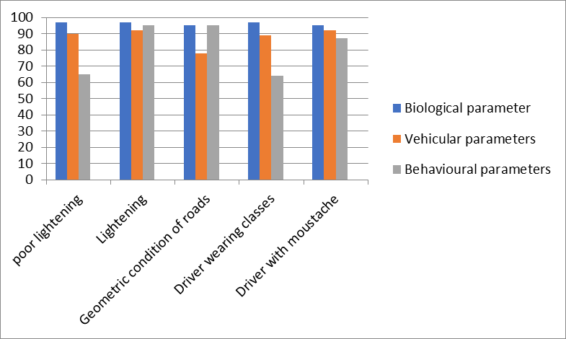A comparative graph is developed from the extensive analysis of sleepiness detection systems based on behavior, vehicle, and biological characteristics shown in the figure below. The effectiveness of each drowsiness detecting technology is demonstrated under various conditions. The circumstances described here are inadequate lighting, proper lighting, road geometry, drivers wearing sunglasses, and drivers with moustaches. This investigation demonstrates that biological parameters produce steady and good results in such settings, whereas behavioural parameters-based systems perform poorly in dim lighting, driving with spectacles, and moustache. The efficiency of biological parameter-based approaches is also diminished when roads are in poor geometric condition.

Figure 3 : Comparative graph of DDT

|  |  |  |  |
| --- | --- | --- | --- |
| Technique | Parameters | Pros | Cons |
| Behavioral Parameters-based DDT | Eye blinking, Eye closeness ratio, Head Movment,Yawning , | Non-intrusive, Easy to use | Effected by illumination,  Lightening conditions |
| Vehicle parameters-based DDT | Steering Wheel behavior, lane changing pattern, yaw angle | Non-intrusive | Effected by  geometric  Characteristics of roads.  Unreliable |
| Physiological parameters-based  DDT | Heart rate, pulse rate, brain activity, respiratory rate body temperature | Efficient, reliable | intrusive |

Table 1: Pros and cons of each technique

## CLASSIFICATION METHODS USED FOR DDT

The classification algorithms and their impact on drowsiness detection systems are described in depth. This section of the systematic review study illustrates the pros and downsides of each classification technique as well as a comparative analysis of error rate in each of them. A thorough examination of classification systems, their advantages and disadvantages, and their graph-based comparison follows. In the drowsiness detection system, various types of machine learning classifiers are employed to train data. The selection of a suitable classifier has a significant impact on the system's efficiency. SVM, HMM, and CNN classifiers are commonly employed in drowsiness systems due to their high accuracy when compared to other classifiers such as KNN, HOG, and others. Each of these three classifiers is addressed in detail.

### SUPPORT VECTOR MACHINE (SVM)

SVMs are the supervised learning approaches for classification and regression. SVMs are first used to choose the training data set from a predefined data set. SVMs learn from categorized data into the classed form of data in sleepiness detection. A variety of measures are employed in the detection and quantification of driver drowsiness. A fully automatic method for detecting driver drowsiness is provided. The Haar feature algorithm is utilised for eye detection and face detection, and SVMs are trained in states such as close, open, and closed eyes to trigger the alarm. This framework achieves 100% accuracy, however it does it at a lower frame rate, which results to the lost facial emotion.

### HIDDEN MARKOV MODEL (HMM)

HMM is a statistical model that predicts the hidden state based on the seen state. HMM is employed in a variety of applications, including facial expression recognition, gene annotation, DNA modelling, computer virus classification, and sequencing mistakes. The features and methodologies employed by the HMM-based Downiness Detector are listed in Table 8. They presented a new facial characteristic that detects wrinkle changes by assessing face intensity. Infrared (IR) webcams are used to reduce fluctuations in both day and nighttime environments. This approach has a disadvantage because elderly persons have deeper wrinkles. Also, the HMM technique is used for tracking the eye based on color and geometrical aspects, however the system fails to recognize the face because the driver is not looking forward and the system is built for indoor use.

### CONVOLUTIONAL NEURAL NETWORKS (CNN)

CNNs are similar to traditional neural networks in that they are built up of neurons that combine with learnable weights. CNN employs the spatial convolution layers chosen most appropriate for the image, resulting in strong correlations. CNN has proven to be successful in a variety of applications, including image identification, classification, and video analysis. CNN was first applied to computer vision by CUN and Yoshua, but the best results for object recognition were achieved in 2012, demonstrating the excellent results in Deep CNN. The suggested system for detecting driver drowsiness employs representation learning, with the Viola and Jones algorithm utilized to detect the face. Initially, the photos are cropped to 48 48 size and then fed up to the network's outermost layer, which has 20 filters. The output is delivered to the SoftMax layer, but the system fails since it does not consider the head pose. However, another author produced a more accurate result by utilizing a 3D deep neutral network in which the face is tackled by a combination of two additional filters; the system works effectively even when the driver switches heads.

Here are detail about Pros and cons of classifiers in tabular form.

|  |  |  |  |
| --- | --- | --- | --- |
| **Technique** | **Parameters** | **Pros** | **Cons** |
| HMM | Probabilities, hidden states., eye state, head position, eye blinks, eye closure | Capture dependencies between the  measurement, able to represent the  variance of the appliance's power | Limited by the intrinsic structure |
| CNN | Eye state, visual features, eye gaze, | Accuracy in the image recognition | Slow to train, need lots of training data high computational cost. |
| SVM | Eye Closure, Eye State, Eye Closure and yawning | Guarantees optimal, abundance  Of implementation. Implicitly, good out-of-sample generalization. | Not suitable large data set, less  effective on nosier dataset |

Table 2: Pros and cons of classifiers

A comparison of the test error rates of SVM, HMM, and CNN classification algorithms is shown. A lower error rate leads to increased efficiency.

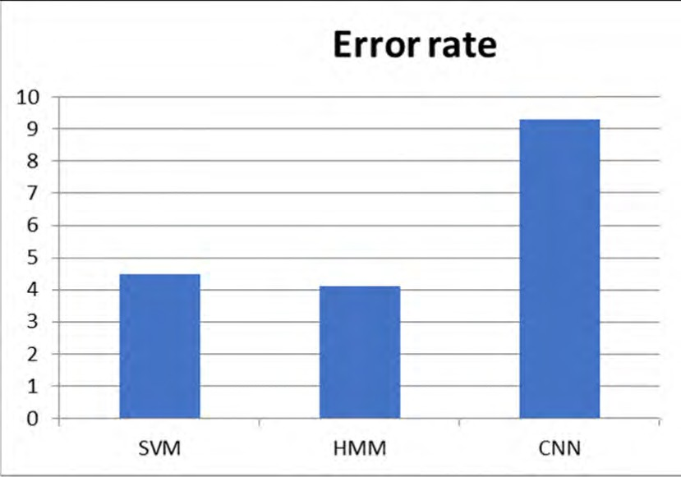

Figure 4: Comparative graph of classifiers

As we are going use CNN method for our project so here is tabular representation of Drowsiness detection systems using CNN.

|  |  |  |  |
| --- | --- | --- | --- |
| **Measure** | **Classifier** | **Description** | **Efficiency** |
| Visual Feature | CNN with SoftMax  Layer | Used voila and Jones algorithm with the CCN and SoftMax layer Of the visual features. | 78% |
| Eye gaze | CNN | Used voila and Jones algorithm with the CCN for the eye gaze. | 98% |
| Eye State | MTCNN and  DDDN | Used MTCNN and DDDN for the eye state detection | 91.6% |
| Eye State | CNN | Used the Ada-boost and LBF and PERCLOS with CNN for the Eye State Detection | 95.18% |

Table 3: Drowsiness detection systems using CNN

# SYSTEM DESIGN

## Use Case Diagram

CAMERA

CAMERA

FACIAL PROCESSING

FACIAL PROCESSING

DROWSINESS DETECTION

DROWSINESS DETECTION

## Activity Diagram

Initialize System

Initialize System

Video Capture

Video Capture

Extract Frames

Extract Frames

Extract Features

Extract Features

Track Features

Track Features

Access Threat

Access Threat

Report Threat

Report Threat

No

No

Yes

Yes

## Class Diagram

**DRIVER**

**DRIVER**

+BlinkingEyes()

+BlinkingEyes()

**DETECTION SYSTEM**

**DETECTION SYSTEM**

**+**Webcam

**+**Webcam

**+**FaceDetection()

+CapturingImage()

**+**FaceDetection()

+CapturingImage()

**ANALYSIS SYSTEM**

**ANALYSIS SYSTEM**

**+**ImageProcessor

**+**ImageProcessor

**+**Extracting Features()

+OpenAndClosedEyeAnalysis()

**+**Extracting Features()

+OpenAndClosedEyeAnalysis()

**ALARM**

**ALARM**

**+**SoundSystem

**+**SoundSystem

**+**StartRinging()

+StopRinging()

**+**StartRinging()

+StopRinging()

**DECISION SYSTEM**

**DECISION SYSTEM**

**+** YesIfDrowsy()

+NoIfNotDrowsy()

**+** YesIfDrowsy()

+NoIfNotDrowsy()

## Block Diagram

IMAGE

IMAGE

Feature Extraction

Feature Extraction

Feature transformation Or Dimensionality reduction

Feature transformation Or Dimensionality reduction

Feature Selection

Feature Selection

Classification

Classification

Drowsy

Drowsy

Get a Reading (Input)

Get a Reading (Input)

No

No

Yes

Yes

# SYSTEM REQUIREMENTS AND SPECIFICATION

## Software Requirements Specification

### Anaconda (1.9)

### Python (3.7)

### Jupyter Notebook (6.0.3)

### Libraries

* + Tesnorflow (2.3.0)
  + Keras (2.4.3)
  + OpenCV (4.5.5)
  + Pygame (2.1.2)
  + Tkinter (8.6)
  + OS
  + Numpy

### Operating System

* + Window OS

## Hardware Requirements Specification

* Laptop with basic hardware (Preferred GPU)
* Webcam
* Mouse/Trackpad
* Keyboard

## Requirement Analysis

### Anaconda

Anaconda is a data processing and scientific computing platform built in Python. It includes a slew of important third-party libraries. Installing Anaconda is equal to automatically installing Python and some often used libraries such as Numpy, Pandas, Scrip, and Matplotlib, making it considerably easier to install than ordinary Python installation. If you do not install Anaconda and instead install Python from python.org, you must also use pip to install individual libraries one at a time. It is painful, and you must consider compatibility, thus it is strongly advised to install Anaconda directly.

### Python

Python is a high-level programming language that is intended to be simple to read and implement. It is open source, which implies that it can be used for free, even in commercial applications. Python is available for Mac, Windows, and Unix computers, and it has also been ported to Java and.NET virtual machines.

### Jupyter Notebook

The Jupyter Notebook App is a server-client application that allows notebook pages to be edited and run in a web browser. The Jupyter Notebook App can be run on a local desktop without the need for internet access (as explained in this paper), or it can be deployed on a remote server and accessed via the internet.

The Jupyter Notebook App contains a "Dashboard" (Notebook Dashboard), a "control panel" exposing local files and letting to open notebook documents or shut down their kernels, in addition to displaying/editing/running notebook documents.

### Google Colab

Colaboratory, or "Google Colab" for short, is a Google Research product. Colab allows anyone to develop and run random Python code in the browser, making it ideal for machine learning, data analysis, and education. Colab, in more technical terms, is a hosted Jupyter notebook service that requires no setup and provides free access to computer resources such as GPUs.

## Libraries

* OpenCV (Face, eye detection)
* Keras (To build our classification model)
* Tenserflow ( Keras use tenserflow as backend)
* Pygame (To play alarm sound)
* Tkinter (Used to develop System GUI)
* OS (OS functions for interacting with the operating system)
* Numpy (Used for Array manipulation)
* PyInstaller (Used for exe development)

### Operating System

-Program is tested on Windows 10 Pro

### Laptop

-Used to run our program

### Webcam

-For getting the video feed

# Implementation

To facilitate high efficiency and accurate driver drowsiness system functionalities, it is divided into:

* Dataset Collection
* CNN Architecture
* Procedure
* GUI Design
* Final Results

## Dataset Collection

The dataset utilized for this model is the open source "MRL Eye Dataset." We created a script that categorized the dataset into two labels: 'Open' and 'Closed.' The acquired data was carefully purified by removing redundant photos. The collection contains over 8000 images of people's eyes taken under various lighting conditions. After training the model on our dataset, the final weights and model architecture file "models/cnn.h5" were attached.

## CNN Architecture

We created the model utilizing **Keras** and **Convolutional Neural Networks (CNN)**. A convolutional neural network is a sort of deep neural network that works very well for image categorization. A CNN is made up of three layers: an input layer, an output layer, and a hidden layer with a variable number of layers. Convolution is conducted on these layers with the help of a filter that performs 2D matrix multiplication on the layer and filter. The layers of the CNN model architecture are as follows:

1. Convolutional layer with 32 nodes and a kernel size of 3.

2. Convolutional layer with 64 nodes and a kernel size of 3.

3. Fully - connected layer; 128 nodes

The last layer is a totally connected layer with two nodes. Except for the output layer, which uses Softmax, other layers utilize a rectified linear activation function (ReLU).

## Procedure

* **Step 1:** Take a picture from a camera as input. Images from a camera are collected using OpenCV and fed into a deep learning model.
* **Step 2:** Find the face in the image and draw a Region of Interest around it (ROI).
* **Step 3:** Detect and input the eyeballs from the ROI to the classifier.
* **Step 4:** The classifier will determine if the eyes are open or closed.
* **Step 5:** Determine if the person is sleepy or drowsy by obtaining a score.

### Step 1: Take a picture from a Laptop Cam as input

We will use a camera to capture images as input. So, in order to access the webcam, we created an infinite loop that captures each frame. We use the technique provided by OpenCV. To access the camera and set the capture object(cap), use *cv2.VideoCapture(0)* & *cap.read()* reads each frame and stores the picture in a frame variable.

### Step 2: Detecting Faces in Images and Creating Regions of Interest (ROI)

To find the face in the image, we must first convert it to grayscale because the OpenCV method for object identification only accepts grayscale images as input. Color information is not required to detect the items. To detect faces, we will employ the haar cascade classifier.

*Face = cv2.CascadeClassifier('path to our haar cascade xml file')* is used to set our classifier face. The detection is then carried out using *faces = face. detectMultiScale(gray).* It produces an array of detections with **x,y** coordinates and height, which is the width of the object's border box. We can now iterate through the faces, drawing boundary boxes for each one.

### Step 3: Extract the eyes from the ROI and input them to the classifier

The same method that is used to detect faces is utilized to detect eyes. We first set the cascade classifier for eyes in leye and reye, then identify the eyes using

*left_eye = leye. detectMultiScale(gray)*

We now need to filter the eyes' data from the entire picture. This can be done by removing the eye's border box, after which we can use this code to extract the eye's picture from the frame. "eye" only holds the eye's picture data. This information will be sent into our CNN classifier, which will predict whether the eyes are open or closed. Similarly, the right eye will be extracted into r eye.

### Step 4: The classifier will determine if the eyes are open or closed

The CNN classifier is being used to forecast the eye state. To input our image into the model, we must first execute certain operations because the model need the proper dimensions to begin with. First, we convert the color picture to grayscale by using

*r_eye = cv2.cvtColor(r_eye, cv2.COLOR BGR2GRAY)*

Then picture is then resized to 24*24 pixels because our model was trained on 24*24 pixel images using

*cv2.resize(r_eye, (24,24))*

We standardize our data to improve convergence.

*r_eye/255 = r_eye (All values will range from 0 to 1)*

To feed our classifier, increase the dimensions. Now for loading our model.

*Model =load_model('models/cnn.h5')*

And then we use our model to forecast each eye,

*lpred = model.predict classes(l_eye).*

If the value of lpred[0] is 1, the eyes are **open**; if the value of lpred[0] is 0, the eyes are **closed**.

*Ipred[0]=1 OPEN , Ipred[0]=0 CLOSED*

### Step 5: Calculate Score to Check whether Person is Drowsy or Not

The score is essentially a value that will be used to assess how long the individual has closed his eyes. So, if both eyes are closed, the score increases; if both eyes are open, the score decreases. We are drawing the result on the screen using

*cv2.putText()*

This feature displays the person's current state in real time.

## GUI Design

The Graphical User Interface of this System is designed using **Tkinter** library**.** Where tkinter window is created and we added 2 menu: **File & About**. File contain *Exit* option while About contain *Driver Cam & Contributor* submenu. If we click any submenu it will trigger command function as bellow:

*subm1.add_command(label ='Exit', command = root.destroy)*

*subm2.add_command(label="Driver Cam",command=About)*

*subm2.add_command(label="Contributors",command=Contri)*

Then main window size is “500x570” .There are two button available in application

* **START DROWSINESS DETECITON**
* **EXIT PROGRAM**

Clicking “*START DROWSINESS DETECITON*” will trigger *def webdetRec(): function that check for drowsiness*  *and* “*Exit Program* ” will trigger *root.destroy()* Which will close the program.

After everything is setup. Now finally we use **Pyinstaller** Library to get a standalone .exe file of our system using command on Tesnorflow CMD if we want.

*pyinstaller.exe --onefile "C:\Users\HP\Documents\Driver Drowsiness\Exe Testing\Drowsiness detection\All file\Driver Drowsiness Detection v1.0.py"*

*It will generate “*Driver Drowsiness Detection v1.0.exe”.

## Final Experiment Results

Here are the screenshot of application and working of app with different scenarios.

### Main Application:

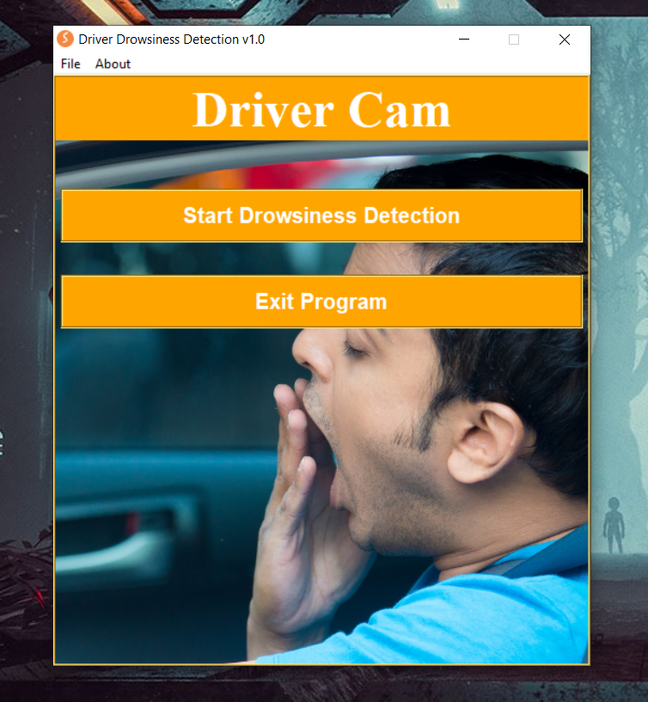

Figure 5: Interface of Application

### App Menus & Submenus:

Figure 6: Submenus

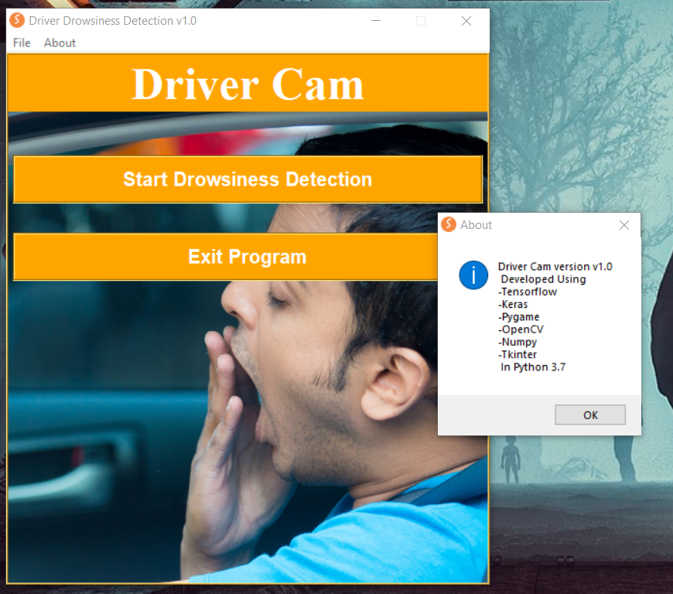

Figure 7: Submenu Clicked

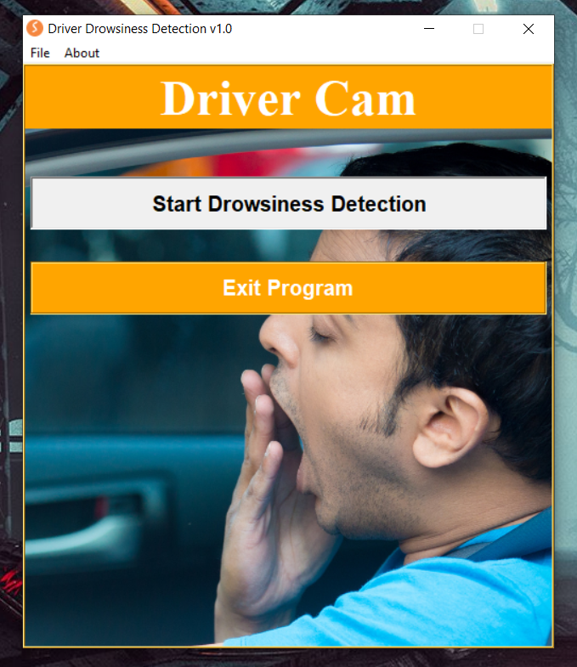

Figure 8: Starting Application

### Open & Close Eye

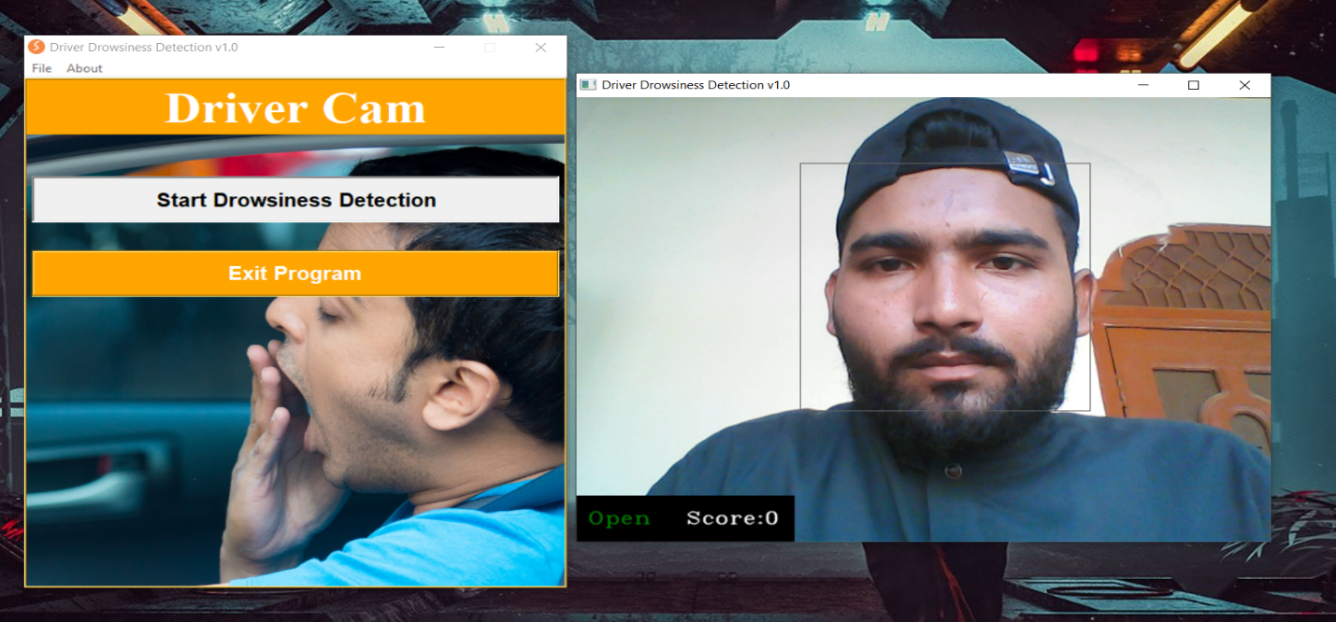

Figure 9: Open Eyes Detection Straight

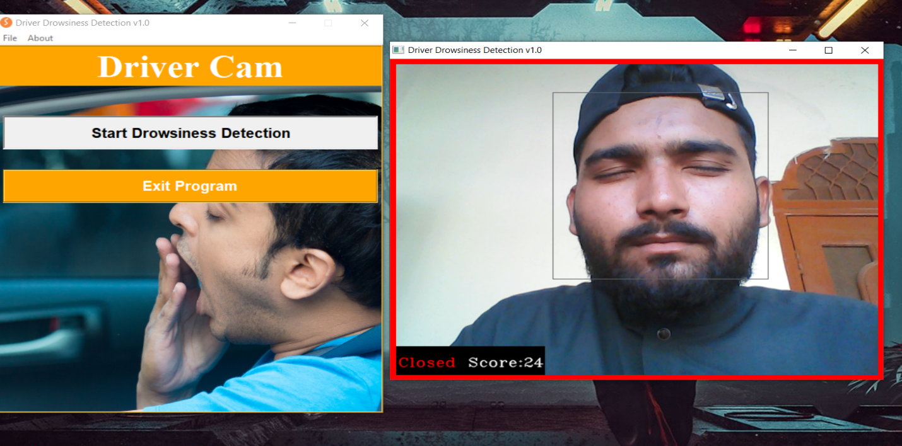

Figure 10: Close Eye Detection Straight

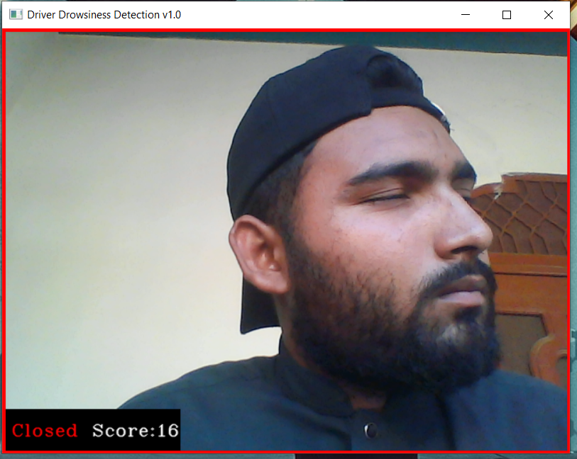

Figure 11: Close Eye Side Pose

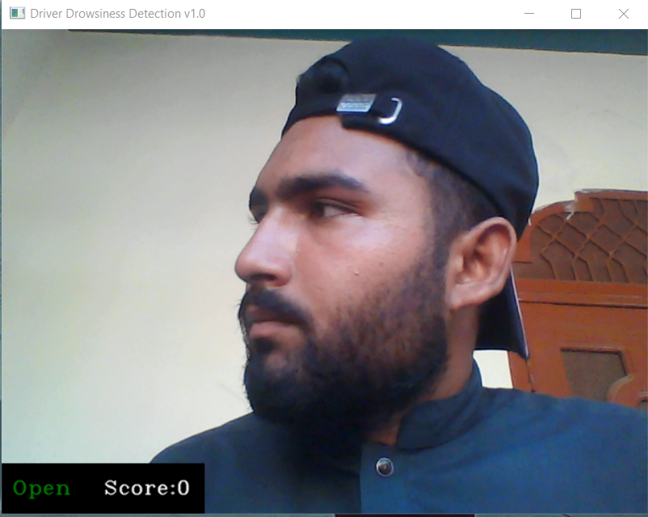

Figure 12: Open eye side pose

### Open & Close Eye With Glasses

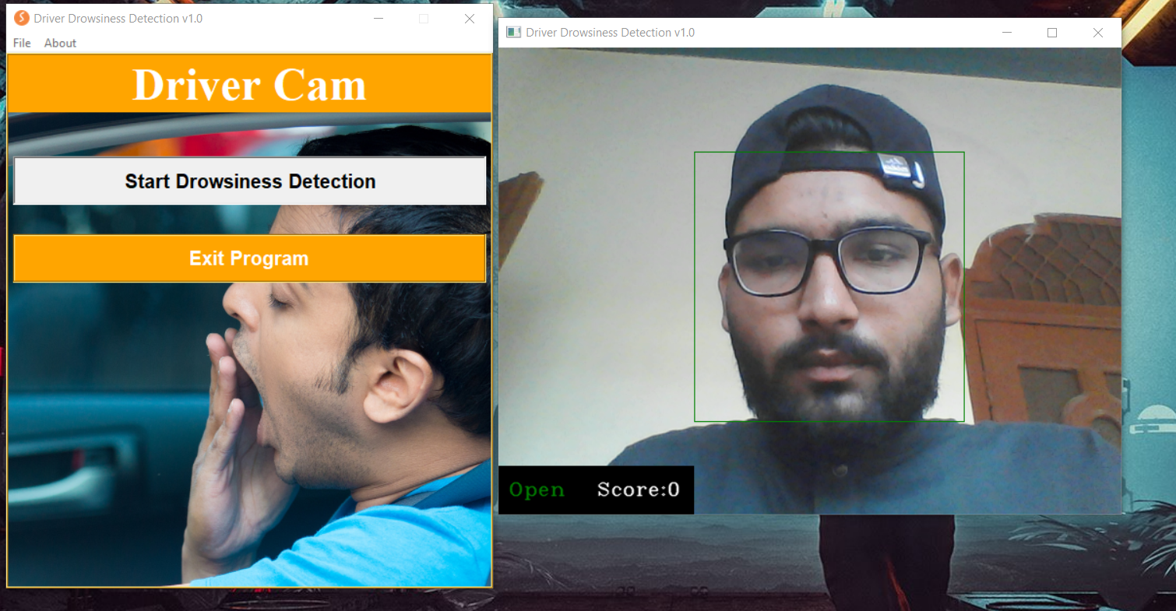

Figure 13: Open Eye With Glasses

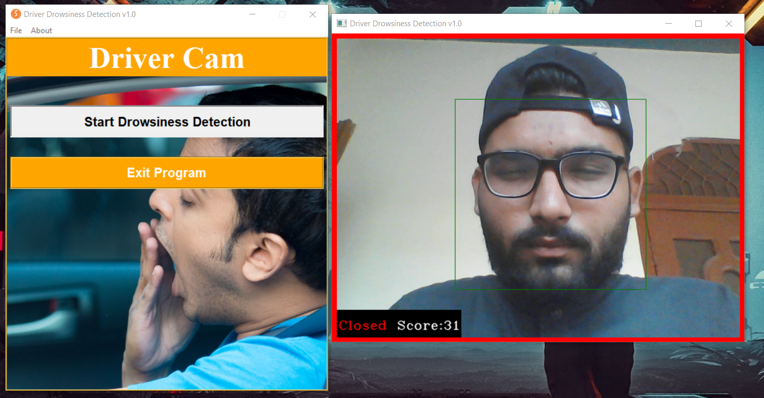

Figure 14:Close Eye With Glasses

# CONCLUSION

Finally, this model help in the prevention of accidents. When a driver becomes drowsy, an alarm is used to prevent him from falling asleep. The risk, danger, and  consequences of sleepy driving are frightening. Driving when drowsy is a risky mix of driving and drowsiness or exhaustion. A fresh concept to detecting human doziness is provided, in which characteristics important for decision making are generated by using multi-layer convolutional neural networks. After successful eye recognition and tracking using computer vision and deep learning approaches, the described model alerts sleepy drivers with an alarm.

The process of detecting driver drowsiness is very important for both individual and community safety. The growing use of Artificial Intelligence can be immensely useful in predicting drowsiness of a driver. Our model automatically predicts a driver as drowsy or not by recognizing and key features from its face and predicting the output in real-time with an accuracy.

## Limitations

The limitations of the system include:

### Ambient light dependence:-

Even if the face is easily detected in low-light circumstances, the system is occasionally unable to detect the eyes. As a result, it produces an incorrect result that must be corrected. To avoid bad lighting circumstances in real-time scenarios, infrared backlights should be used.

### Optimal range required:-

When the distance between the face and the webcam is not optimal, some issues arise. When the face is too close to the webcam (less than 30 cm), the system cannot detect the face in the image. When the face is more than 70cm distant from the webcam, the backlight is insufficient to effectively illuminate the face. As a result, eyes are not identified with great precision, showing an error in detecting fatigue. This issue is not treated seriously since the distance between the driver's face and the webcam in real time is less than 50cm, hence the problem never occurs. Given the difficulties mentioned above, the best distance range for detecting sleepiness is (40-70) cm.

### Hardware requirements:-

We need a camera that can recognize faces and so extract eye coordinates. If the system is not properly configured, the procedure may be snappy and sleepiness detection may be slow. The issue was overcome by utilizing dedicated hardware in real-time applications, which reduced the need for frame buffering and delayed detection.

### Problem with multiple faces:-

If the webcam detects more than one face, our algorithm produces an incorrect result. This is unimportant since we only want to detect tiredness in a single driver.

# REFERENCES

1. M. Ramzan, H. U. Khan, S. M. Awan, A. Ismail, M. Ilyas and A. Mahmood, "A Survey on State-of-the-Art Drowsiness Detection Techniques," in IEEE Access, vol. 7, pp. 61904-61919, 2019, doi: 10.1109/ACCESS.2019.2914373.
2. BAHARU, BADIUZAMAN (2013) “DRIVER DROWSINESS DETECTION BY USING WEBCAM” Universiti Teknologi Petronas
3. Z. Ahmad Noor Syukri, M. Siti Atiqah, L. Fauziana, and A. Abdul Rahmat, "MIROS crash investigation and reconstruction: annual statistical 2007-2010," 2012.
4. A. Picot, S. Charbonnier, and A. Caplier, "On-line automatic detection of driver drowsiness using a single electroencephalographic channel," in Engineering in Medicine and Biology Society, 2008. EMBS 2008. 30th Annual International Conference of the IEEE, 2008, pp. 3864-3867.
5. G. Borghini, L. Astolfi, G. Vecchiato, D. Mattia, and F. Babiloni, "Measuring neurophysiological signals in aircraft pilots and car drivers for the assessment of mental workload, fatigue and drowsiness," Neuroscience & Biobehavioral Reviews, 2012.
6. LEIBOR, PAUL L. "DRIVERS DROWSINESS DETECTION SYSTEM. " Coursehero, www.coursehero.com, 16 Apr. 2017
7. Sharma, Rizul & Agarwal, Pratyush. (2019). "DRIVER DROWSINESS DETECTION SYSTEM".
8. Mehmood, A. (2021, November 21). "Alarming figures of traffic accidents need attention". thenews. Retrieved July 12, 2022, from "https://www.thenews.com.pk/print/910436-alarming-figures-of-traffic-accidents-need-attention"
9. Kavyashree Subramonian, G. Sumathi " Drowsiness Detection System with Speed Limit Recommendation using Sentiment Analysis" International Journal of Recent Technology and Engineering (IJRTE)**,** May 2021
10. K.Yamini , T.Vivek "MINI PROJECTONDriver Drowsiness Detectionand Safety Alert SystemUsing Python" , Feb 2021